## **Hands-On Activity: Exporting your R Markdown notebook**

**TOTAL POINTS 1**

1.

Question 1



Now that you have finished creating a draft of your R Markdown notebook, it is time to export and share it. For this activity, you will export your notebook to two different outputs--HTML and PDF. After you have exported your notebook, you will share it with a trusted friend or colleague to get feedback.

### Exporting your R Markdown notebook



For this activity, you will be using the existing notebook that you have been working with and exporting it as both an HTML document and a PDF.

In order to export your notebook, you will use the knit option. This will allow you to convert the .Rmd file to another file type that is more readable and useful to other users.

You will find the Knit button on the toolbar at the top of your document window--it’s indicated with an icon of a ball of yarn. When you click it, it will open a dropdown menu with a few export options. Click on the option that matches the file type you want to export your notebook as. Once you click the Knit button, your console might take a moment to process. Then, once it is finished, it will automatically open your new file.

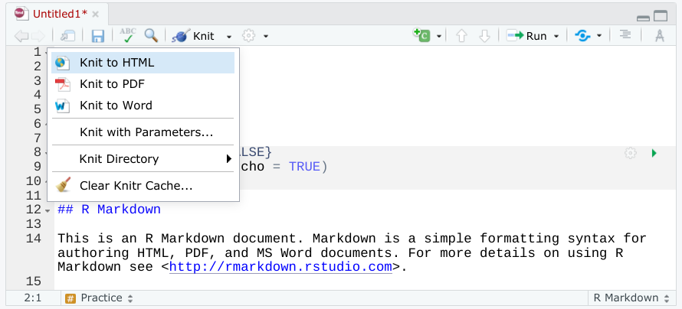

Try exporting your notebook as both HTML and PDF and explore how these file formats are different from your original .Rmd file.

After you have successfully exported your RMarkdown notebook, share it with a friend or colleague to get feedback. Continue the conversation after you have gotten their feedback, make revisions, and continue to share your work to refine your notebook even more.

Sharing your RMarkdown notebook is a great way to give other users insights into your data analysis. RMarkdown comes with a lot of different options for exporting notebooks, too, so you can choose the best file type for your needs.

## Did you complete this activity?

**1 / 1 point**

Yes

No

**Correct**

Thank you for completing this activity! Understanding how to export your RMarkdown notebooks will make documenting and sharing your data analysis process easier. Now you should be more familiar with this process, so you can export your own notebooks in the future.